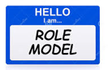
Who can I be a role model for?
Who is my role model?
(you can have more than one!)

TO:
FROM: ________________________
What makes a good role model? (qualities)

1.
2.
3.
4.
5.
What is a role model?

