2020

Edmonton Southside Primary Care Network

6/30/2020



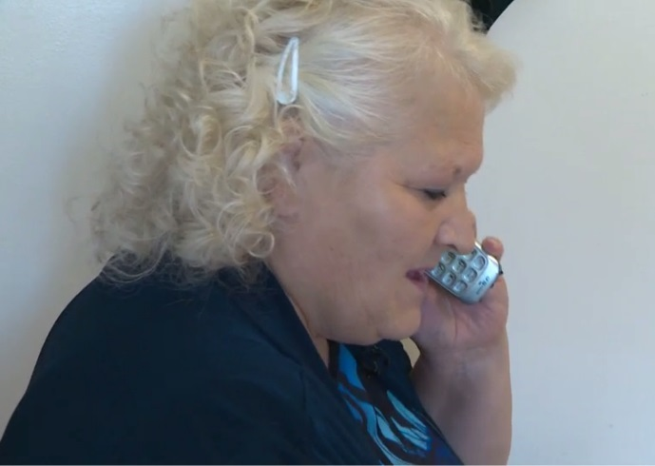

Seniors' Centre Without Walls Toolkit

Acknowledgments:

**How to Use the Toolkit**: The Seniors’ Centre Without Walls toolkit provides a step by step guide to planning, establishing, running and evaluating telephone-based seniors programming for homebound or isolated seniors. This toolkit is meant to disseminate learnings from both the New Horizons for Seniors grant funded project and the expansion, funded through the Aging Well in Community, established in Edmonton and run through the Edmonton Southside Primary Care Network. The information below is meant to guide organizations interested in running a Seniors’ Centre Without Walls (SCWW) or similar style of programming in both community and health settings.

The manual provides an overview of outreach services and provides necessary background information related to working with isolated and at-risk seniors.

**Toolkit Feedback**: We value your input! Please take the time to provide us with your feedback, comments and suggestions.

Contents

Acknowledgments 1

1.0 Introduction 3

1.1 Background 3

1.2 Benefits of Program 4

1.3 Setting 4

2.0 Essentials of Getting Started 5

2.1 Scope of Project 6

2.3 Technology 8

2.3 Cost Projections 11

2.3 Participant Recruitment 12

2.4 Presenters & Guest Speakers 14

2.5 Subpopulation Specific Programming 15

2.6 Topic Selection 16

2.6 Frequency & Durations 18

2.7 Class size 19

2.8 Facilitation Role & Styles 19

2.8.1 Policies & Procedures for in Group Emergencies 20

2.9 Mail-outs 21

2.9.1 Program Books 22

3.0 Administrative Considerations 24

3.1 Registration 24

3.2 Activity Tracking 24

4.0 Development & Evaluation 25

4.1 Participant-led Advisory Group 25

5.0 Sustainability Recommendations 27

Appendix A – Programs Descriptions & Frequency 29

Appendix B – Example Program Books 35

# 1.0 Introduction

Social isolation and loneliness are health risks and having more supportive social relationships is related to a decreased mortality risk1. A lack of social relationships is as strong a risk factor for mortality as are smoking, obesity or lack of physical activity1. While this is a risk across the lifespan, older adults are at increased risk of being socially isolated and one in five Canadians aged 65 or older indicated that they felt lonely some of the time or often in a recent study4. The majority of older adults, particularly women, live on their own with shrinking social networks. This risk can increase surrounding critical life events, such as retirement, change of residence, loss of driving licence or vehicle, children and grandchildren moving away, or death of a spouse, friend, sibling or even pet. Older adults who are lonely have an increased risk of dying sooner and are more likely to experience a decline in their mobility, compared to those who are not lonely2,3.

The need to build stronger relationships with those who may have limited social connections was evident in our organization within our older adult population, particularly surrounding the loss of a spouse, passing of friends, and change in living situation or health status. A baseline survey of older adults in Edmonton found the 24% of them felt lonely on a regular basis4. While indicators of isolation such as withdrawal, loneliness, and the use of appointments as social support visits could be noted, there are often profound barriers to these seniors’ ability to increasing their connectedness within the community; particularly for those who had a difficult time leaving the home. This issue is compounded when seniors are caregivers or live in rural communities, areas with less accessible transit or have limited income. A multitude of personal health and environmental risk factors may contribute to someone becoming socially isolated; a very personal experience which indicated the need for interventions with more flexibility and choice for the individual.

## 1.1 Background

The first Seniors’ Centre Without Walls (SCWW) developed in the United States of America, and programs of similar ideology and methods have been created all across North America. Most of these programs collaborate through the Without Walls Roundtable, hosted by [the SCWW in California](https://covia.org/services/well-connected/), in order to share learnings, coordinate programs and further the development of smaller programs. The names of programs vary with respect to their purpose – for instance, if the intent of the call is for general discussion and education, the name is not specific. If the calls are concerning support or to alleviate loneliness, the program name reflects this.

At its core, a SCWW is a telephone-based program offering a variety of interactive social and health programming, free of charge or at a minimal charge to seniors 55 years and older. The goal is to support social connections for seniors who are homebound or isolated, building an inclusive community atmosphere and ensuring accessibility of social opportunities and health/wellness information to all seniors. By gathering seniors from a geographical range on conference calls together, we are expanding the social experiences of patients in addition to building relationships with participants to find ways to better support their needs.

## 1.2 Benefits of Program

Telephone programming has been identified as a potential intervention for social isolation by the Government of Canada ([2017](https://www.canada.ca/en/national-seniors-council/programs/publications-reports/2017/review-social-isolation-seniors.html)). Individual evaluations have demonstrated positive results, but are limited to post intervention questionnaires, descriptive literature or reports of success based on participant self-reporting. The results of this pre/post evaluation show that the SCWW can have a statistically significant (p<0.05) reduction in feelings of isolation and anxiety/depression, and improvement to feeling valued by family/friends and self-realization and energy levels.

In addition, we have noted that the impact of the program varies depending on the engagement level. High users as a group, experience more barriers/concerns and risk factors of isolation, such as low income or lack of contact. These participants showed the highest improvement at follow up measurement, in feelings of connection with and valued, engagement in meaningful activities. There was also a statistically significant improvement in the total UCLA loneliness score for High Users of the program.

## 1.3 Setting

Given the negative impact that social isolation and loneliness can have on older adults, it is not surprising that social participation and inclusion were identified as important indicators of age-friendly cities by the World Health Organization (WHO, 2007). From this perspective, addressing the social problems of social isolation and loneliness can and should be done at the community level. Most of the organizations offering teleconferencing or video conferencing for seniors are not-for-profits and utilize partners with a variety of like-minded community organizations in order to find their clientele. These partners may include non-profit organizations, community centres, health-based organizations and/or academic institutions.

In North America, those SCWWs who are part of the Without Walls Roundtable, there is a wide range of settings which programming is run out of. Most would fall under the umbrella category of community based social services. Ours was unique in that it is the first SCWW run from a multidisciplinary health institution in Canada. This gave us a direct referral pathway to a wide range of clinicians (nurses, dietitians, social workers, respiratory therapists) many of who could identify patients they currently worked with who were socially isolated, however their interactions were limited to individual home visits and appointments there was no clear resource to work with these patients toward increasing their connectedness within the community; particularly for those who had a difficult time leaving the home. This also gave us a pool of speakers to pull from, to provide quality health education programs to our seniors and to start off our programming. It has also lead to the development of health behaviour (Relaxation & Home Exercise) and disease specific support groups (COPD).

# 2.0 Essentials of Getting Started

## 2.1 Decide on Scope of Project

This scope may change as your program matures and as new opportunities emerge. Our program started in 2016 with a Federal grant focused on local regional interventions and we made our shift to provincial expansion in 2019 with assistance from a provincial grant from the Alberta Ministry of Seniors & Housing.

|  |  |  |
| --- | --- | --- |
| Municipal | Provincial | Nationwide |
| * Focus on a specific town or county for both participant recruitment and programming topics. * Makes it easier to tailor to specific needs of local seniors and highlight local resources. * Less access of funding options. | * Open up to participants from anywhere in province. * Usually second step or expansion of pilot. * Not necessarily more expensive than local as cost is linked more to volume. * Relationship building essential to properly spread the word and find referral partners. * Wider range of presenter options, recruitment sources and funding options. | * Open to anyone in a specific country. * Greater risk of stepping on other programs, duplication of services. * Harder to tailor to needs and make sure resources highlighted are appropriate for everyone. * More difficult to find and sustain relationships with partners. * Will need more lines and programming to deal with potentially volume. * May want to focus on seniors with more technology access as mailing may be difficult at this scale. |
| Example: Ottawa’s SCWW | Example: Manitoba’s based out of Winnipeg, Alberta’s based out of Edmonton. | Example: COVIA’s Well-Connected based out of California, Dorot University’s out of New York. |

2.2 Staffing Roles

**TIP**: The scope of these roles will vary greatly depending on whether or not the SCWW is funded internally or through external grant funding. Grant funding comes with additional reporting, evaluation & finances expectations which require more work to accommodate. In-house funding usually means in-house mechanisms for activity reporting, administration & accounting.

Depending on the scale of the program, the following may be a comprised of multiple stand-alone full-time positions, or these responsibilities may be distributed between part-time positions or rolled into an existing role. Initially, our program began with a single staff person (1.0 FTE) handling all roles associated with the program until the growth/participation levels justified the addition of an assistant position (0.75 FTE). Further addition or redistribution of FTE between the roles occurred during the provincial expansion in 19/20.

*Coordination*: The main focus of this role is partnership building, referral pathways, reporting, documentation, project management, budgeting, maintaining progress and expanding scope strategically, as well as planning new series. It is important for staff within the program to create awareness and mobilize community interest and support for seniors. Engagement and collaboration should go beyond systems and agencies to include businesses, neighbourhood groups, community organizations, and volunteers. All of these partnerships will be crucial to raise awareness of the program, recruit participants and guest speakers to round out the program offerings.

*Facilitation*: This is a critical role that all staff on the project will need to be trained in and be comfortable performing. It is very important that multiple individuals are training in the teleconferencing technology, how to troubleshoot technical issues, how to use the features and run a call; to ensure the program can run consistently while staff are on vacation, off sick or just splitting the time requirement to allow for other roles as needed. Facilitation also includes the skills of group management, fostering conversation and assisting guest speakers in maintaining a pleasant and accessible environment on the calls. Selection, training and support for call facilitators is a must. Facilitators need dedication, enthusiasm and skill to manage the conversation and include everyone on the call. This can be challenging as you are lacking the visual and body language cues that many facilitators rely on and takes some time and practice to become comfortable with. Peer mentorship and shadowing is an important tool in training of new staff, in particular in the nuances of each program and facilitation style.

*Outreach & Support*: This role developed as we began to work with our participants to improve the accessibility of services to seniors. Socially isolated seniors may not feel comfortable reaching out to other services directly, and we found after the initial relationship was built with us, we became a source of support and information for those who did not have other options. Outreach is also about reaching out to participants who may need assistance or additional information, given our interactions over the phone and on group calls. Sometimes the outreach involvement with a senior is very short-term, like a check in call on an individual who has missed a few calls; other times needs are on-going, supporting a client after the passing of a spouse or while navigating the care system.

**TIP**: It is up to the organization to decide whether or not this role is within their scope or capacity, but staff should always be knowledgeable about community supports and be prepared to make recommendations and referrals as needed. Sometimes you are the only point of contact of a senior and their only source of guidance.

*Administrative & Data Entry*: Again, this role will depend on your organizations expectations of privacy, software security and administrative capacity. Health organizations often have stricter expectations of privacy and the program may need to adopt whatever patient management system is currently used within the systems, then exporting data on participants and attendance into other forms for analysis and tracking. It is also up to the program to decide on who will handle registration of participants, or whether registration will be required for all programs. At its base level, there will need to be capacity in the program to register participants, answer participant inquires and cancelations, complete intake surveys/follow-up surveys, enter activity data and clean participant data for analysis.

## 2.3 Technology

In general, teleconferencing is the most accessible technology for connecting isolated or housebound seniors. The telephone is one of the most common, trusted, and ubiquitous communication technologies available. Within the SCWW programs, teleconferencing was found to be accessible and easy to use with very few, if any, barriers. SCWW currently uses the most recent version of Zoom, Zoom 5.0.2, to run their programs, with several features modified or turned off to avoid uninvited guests and to increase the security of the calls (Masking Phone Numbers, Disable “Join Before Host”, Disable AutoSaving chats, Disable file transfer, Disable screen sharing for non-hosts, Disable remote control).

**TIP**: The anonymity of being a voice on a call instead of attending in person or a visual component, allows for a sense of privacy and security for our participants. This is particularly useful for the discussion of sensitive subjects such as elder abuse, mental health support, and LGBTQ+ issues.

While online communications might afford more possibilities such as video cameras and online messaging, the assumption cannot be made that everyone has a computer; or that everyone is comfortable communicating online. This creates a financial barrier to participation as many low-income seniors, cannot afford either a computer or an internet connection. At a focus group conducted in May 2020, seniors noted that appearing in front of a camera can add extra pressure and create stress or anxiety; a risk that is minimized through the use of the telephone. The focus group sought to understand seniors’ perspectives on the use of telephones or video conferencing methods of attending programs and no clear consensus was drawn. Ultimately, it was believed that personal preference and available resources were the main predictors of which method was adopted by the seniors. SCWWs in the USA have used video technology to run ALS programs. If video technology will be used, extra privacy concerns will need to be addressed. For example, extra additions to the code of conduct to cover what is okay to appear on camera, ensuring the background of videos are appropriate, and what steps the facilitator will take to ensure the safety and enjoyment of the calls.

**CAUTION**: Other SCWW have chosen to work with a technology that allow participants to chose whether to call in on the phone or join through a webpage (Zoom, Skype for Business, etc.). This can cause issues with unequal participation & requires active facilitation to allow everyone to participate equally. However, when trialled in May 2020, participants were asked about interaction patterns when some participants join via video and others join by phone. They agreed that as long as programs were facilitated well, they felt included in the programs.

**TIP**: Always include a disclaimer as we cannot guarantee the security of any individual technology when data is being share. For example:

**PRIVACY DISCLAIMER:** This program uses video & audio technologies for sessions rather than asking for participants to come into a building. We do our best to make sure that any information you give to us during programs is private and secure, but no video or audio tools are ever completely secure. There is an increased security risk that your health or personal information may be intercepted or disclosed to third parties when using video or audio communications tools.

At the minimum, the service you choose should have a visual web portal which allows hosts to view the calls, displays the names of those participating and additional control abilities for the host. While each company will offer a different range of web or telephone controls, at the minimum you should be looking for the following:

* Dial-Out to Participants
* Lecture Mode
* Recording & Playback
* Breakout Rooms
* Capacity to Mute Participants
* Audio Sharing

Many platforms, including Zoom, enables facilitators to split participants into ‘breakout rooms’, i.e. smaller groups. This is beneficial when large groups want to participate in games such as BINGO, Family Feud, or Jeopardy. This feature allows the facilitators to each work with one group and makes gameplay smoother.

Audio sharing allows facilitators or guest presenters can share audio from their computers, either through uploaded MP3s or through computer’s audio programs or webpages. This is beneficial for exercise programs, music trivia-type programs, or for sharing audio components of videos that enhance participants’ experience and/or learning in programs.

Essentially facilitators must have the option to mute participants to eliminate background noise during programs. This helps programs run more smoothly because it means that less interruptions are experienced overall.

The dial out feature is critical, not only to increase attendance but also increase accessibility. Many participants who can benefit from this program are experiencing memory issues and therefore find it difficult to dial themselves into the system at the correct time. Others still have vision issues or other physical limitations and cannot easily dial the toll-free number and enter the passcode on the touch pad.

**TIP**: Call-Outs can also allow staff to track those who have missed several session and flag them for follow-up and outreach. Even if participant cannot attend the session, they were called for it is an opportunity for staff to connect to participants, find out what is going on in their lives and build the relationship.

Lecture mode mutes all participants other than the host line, cutting down on background noise on the call and minimizing interruptions from participants. This is only useful in presentation style programs but can be an important tool to maintain quality of the call.

The recording feature is beneficial when sessions are led by guest speakers or one-time presentation and you would like to capture that material to play at a future date. These are stored and can be downloaded as mp3 files. Additionally, you can upload your own mp3s of talks, clips or music to be played over the system and evenly heard by all participants. Guests should be asked for consent to record their presentations especially if they are representing an organization (see below).

|  |
| --- |
| **Consent to Use and Disclosure of Seniors' Centre Without Walls Program Recording and other Personal Information for Promotion and Programming**  I, (name of person), hereby consent to my personal information (including a photographic or video image or images of myself) being:  1. used by the Primary Care Networks (PCN) and in accordance with:   1. section 39 (1), 33 (C) of the Freedom of Information and Protection of Privacy Act (FOIP) and/or 2. sections 7,8 and 9 of the Personal Information Protection Act (PIPA) of Alberta; and/or   2. disclosed by PCNs to a third party (e.g., design firm, audio or video production company) for the sole purpose of producing PCN promotional materials, in accordance with section 40(1) (d) of FOIP  This initiative may take the form of the following:   * still/digital photographs * sound recordings * video recordings (with or without sound)   The initiative may be written for the following purpose(s):   * SCWW programming * promotions * presentations * displays * websites (both PCN and PCNs)   Promotions for the program may appear in social media applications, including but not limited to: Twitter, Facebook, YouTube  I acknowledge that I have been made aware of the reasons that my personal information (including a photographic image or images of myself) is needed and the risks and benefits of consenting to the use and/or disclosure of the same.  I release and discharge the PCNs, and those for whom each is responsible at law, from all responsibility and liability for the content of the above mentioned still/digital photographs, video recordings and/or sound recordings and the specific use to which they may be applied. I declare that this release and discharge shall be binding upon my heirs, executors, administrators and assigns.  I understand that I have the right to refuse to grant this consent. I understand and confirm that I may revoke this consent at any time by contacting Communications at telephone number or by email.  Other relevant restrictions or conditions you may have regarding the use of your recording:  __________________________________________________________________________________  This consent is effective this: ___________________________  Signature: ____________________________  Address & Email: ____________________________________________________  I confirm that PCN and/or PCNs may use my name, address and telephone number for the purpose of contacting me to discuss any changes in circumstances which may be relevant to this consent. |

## 2.3 Cost Projections

The actual cost for providing the teleconference (technology required, service, etc.) depends on the cost model of the individual service provider. Most service providers have a Plan-Based financing either around a level of service or a by usage system. For example, MERCURI offers a per minute/per line, allowing for the prediction of cost per program and extrapolation to decide on amount of programming. Zoom offers a set yearly/monthly rate for unlimited use.

**TIP**: Be aware of minimum usage clauses in agreements particularly when starting up and around holidays when there may not be as many participants.

Most of the programs on offer are free to seniors; however, there are a few organizations that operate on a subscription basis and charge a monthly fee. As this program is of particular use for low income seniors or those on a limited budget, we recommend that organizations offer the program at no cost to participants. As aside from staffing salaries, the largest cost is covering the cost of teleconferencing. For costing purposes, a scaled approach is best. Begin with the minimum that you can start with and find the upper limit to decide up capacity restraints. For example:

|  |  |  |  |  |  |
| --- | --- | --- | --- | --- | --- |
| Stage | # of Programs/mth | # of minutes/mth | # of participants per call | Cost per minute/line | Cost per month |
| Pilot | 4 | 240 mins | 5-6 | $0.05 | $96 |
| Stage 1 Expansion | 8 | 480 mins | 7-8 | $0.05 | $192 |
| Stage 2 Expansion | 12 | 720 mins | 8-10 | $0.05 | $360 |
| Stage 3 Expansion | 16 | 960 mins | 10-12 | $0.05 | $576 |
| Upper Limit | 20 | 1200 mins | 12-15 | $0.05 | $900 |

## 2.3 Participant Recruitment

Socially isolated seniors, by definition, are difficult to locate and require some extra work technique to reach them. Overall, we have found that many SCWWs are most successful through organizations & agencies that already have some established seniors network/following; also featured programming on the facilitator organization web site; also, through social media (Facebook; Twitter).

**TIP**: Take advantage of media interest in older adult issues to get the word out about your program. By reaching out to health reporter at local and provincial news agencies, we have had 3 video news clips, 2 write ups, & 1 radio interview, resulting in incoming participants unconnected to any other seniors’ services.

The needs and challenges facing the seniors who may benefit from our program are best addressed by the entire community. These programs can run on their own and grow, however this limits the reach and topics that they can offer. We encourage and embrace the chance to try and raise awareness of the complex issues that surround social isolation of seniors, and to help SCWW staff better support their own participants. Try to focus recruitment on awareness building and cross-agency referrals, as this is helpful for marketing purposes and identification of participants.

Go where seniors gather and prepare to get to know your community. What seniors’ information/wellness events should you attend, what food courts or mall walking groups, public spaces and services that seniors often access? While homebound seniors are less likely to be access these events, often the program may be appropriate for friends or family members of those who are attending. Being able to get promotional materials out through services that come into the homes of homebound seniors can be a great recruitment tool, including sending material with Meals on Wheels, or with housekeeping services run through community organizations.

Establish strong relationships with organizations and associations that work with older people in your community, particularly those while an outreach component and/or see seniors who are at critical life events. Be sure to meet representatives of organizations to explain the program as it is not always easy to grasp from the name and try and attend front line staff meetings to discuss the relevance to their work and answer any questions they have.

|  |  |
| --- | --- |
| Awareness | Referrals |
| Seniors’ Centres | Geriatric Recreational Therapists |
| Community Leagues | Family and Community Support Services |
| Volunteer Driving Organizations | Home Care Workers |
| Meals on Wheels/Food Services for Seniors | Primary Care Networks/Doctors’ Offices |
| Public Libraries | Rehabilitation Occupational Therapists |
| Places of Worship (Churches, Temples, Mosques, Synagogues etc.) | Seniors Outreach Workers |
| Seniors Directories of Services (printed, web and telephone based) | Hospital Discharge Staff |

**TIP**: Prepare printed materials to be provided to and distributed by referral partners. Oftentimes these individuals are including this information during a visit where multiple topics/resources are being discussed and providers may have trouble recalling all details provided to them early. Examples of versions we used and refined are given below.

**Version 1**: Postcard, too little information to be useful by potential participant, providers unable to explain and give details about the type of topics provided and not visually interesting enough to encourage participant action.

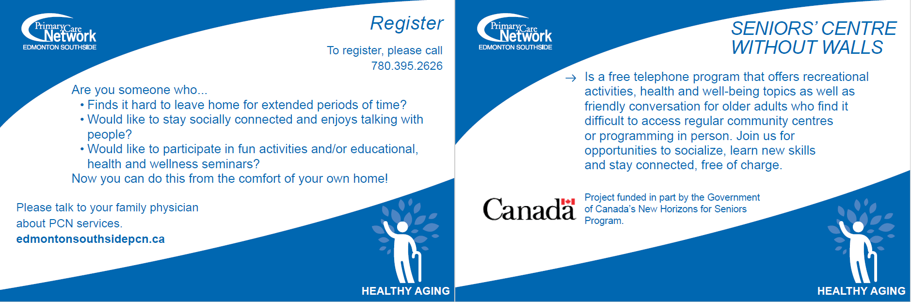

**Version 2**: Still short, single page (double sided), provided to providers in tear off pads – a format they were familiar with, listed examples and visual diagram of how the program worked. 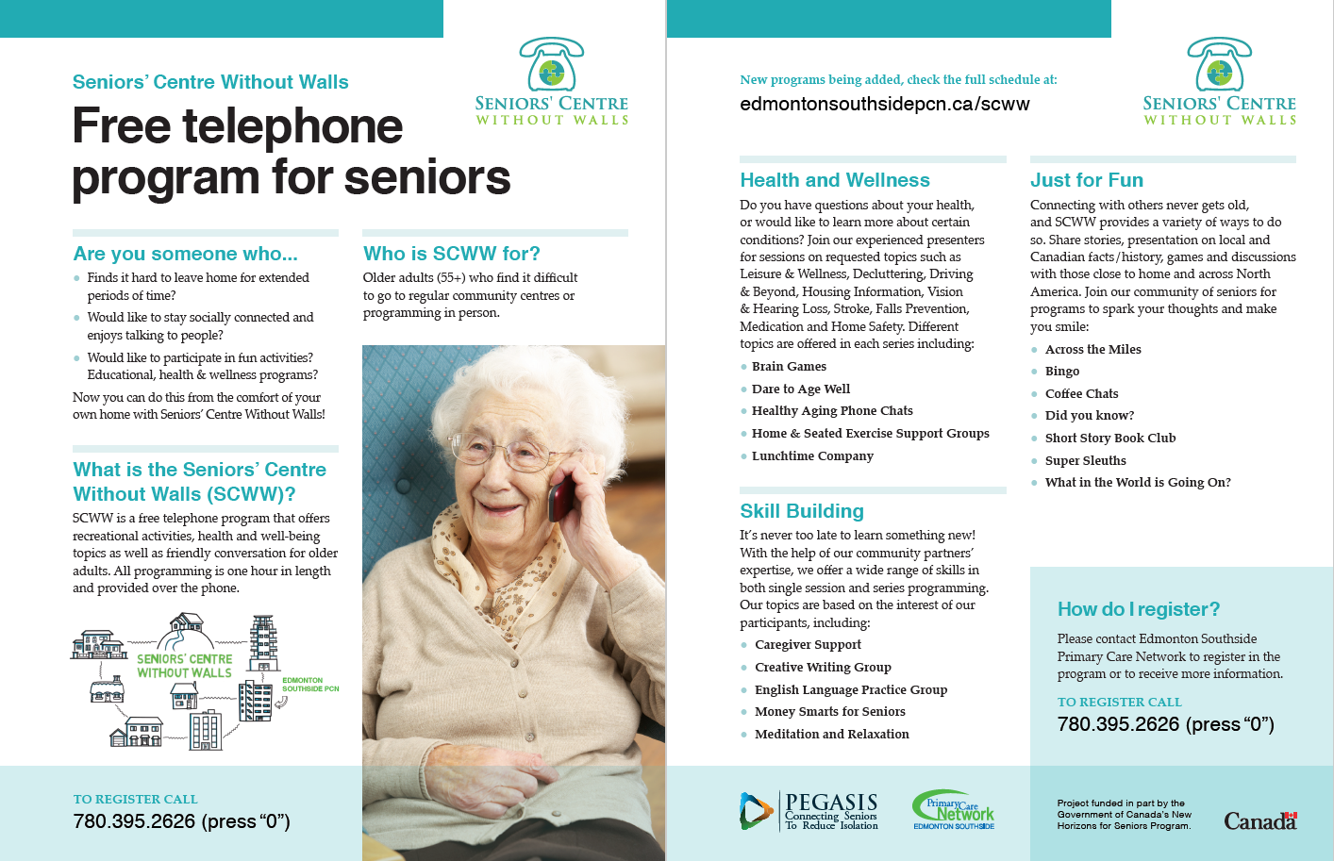

## 2.4 Presenters & Guest Speakers

|  |
| --- |
| *Alberta Health Services* |
| *Alberta Motor Association* |
| *Alberta's Seniors Advocate* |
| *Alzheimer Society* |
| *Arthritis Society* |
| *Austin Family Eldercare* |
| *Balance Your World* |
| *Beringia Museum* |
| *Bridges Support* |
| *Canadian National Institute for the Blind* |
| *Canadian Parks and Wilderness Society* |
| *Caregivers Alberta* |
| *City of Edmonton* |
| *Diabetes Society* |
| *Edmonton Mennonite Centre for Newcomers* |
| *Edmonton Police Service* |
| *Edmonton Public Library* |
| *Edmonton Transit Services* |
| *Frank Slide Museum* |
| *GeriActors Theatre* |
| *Good Samaritan Telecare* |
| *Government of Alberta* |
| *Home Care Recreation Therapists* |
| *Leduc #1 Energy Discovery Centre* |
| *Meals on Wheels* |
| *Millwood’s Seniors Centre* |
| *North American SCWWs* |
| *North West Edmonton Seniors Society* |
| *Seniors Association of Greater Edmonton* |
| *Southside Primary Care Network* |
| *Telephone Historic Centre* |
| *University of Alberta* |

**TIP**: Creativity is key and you will always be surprised at who will respond favourable. It is an easier sell than getting speakers to come out to in person sessions, as we have no travel time or parking. Presenters can call in from wherever they are as long as there isn’t too much background noise.

When planning a series, it is important to use guest speakers strategically to keep presentations interesting and to stretch your capacity, to offer more without overburdening staff. Initial programming for your pilot of early sessions may easily be run by program staff, however as the frequency increases and number of attendees grows, it will be crucial to the success of your program to leverage local professional volunteers.

Often time these speakers were recruited by program staff after a request for a topic emerges from participants or after staff learn of an interesting project or group. Guest speakers can give one off presentations, return on a set interval to repeat talks, or run regular programming every month. It is up to the presenter and the suitability of their topic(s) for consistent programming. Libraries, local interpretative centres, museums or clubs are a wonderful source of interesting talks who have a focus on serving the community. Health organizations and disease specific societies are a good resource for professionals to give healthy aging information. Academic centres, like universities or colleges often have professors or grad students excited and willing to give talks on their research or coursework, in particular those studying topics related to seniors’ health (gerontology, occupational therapy or recreation therapy) or just interesting topics (music, history, animals for example).

**CAUTION**: Occasionally business professionals will approach, offering to give talks. You can accept these as long as the presenter agrees to: 1) not promote their services/give a sales pitch, 2) spoke on a topic that was of interest/need identified by our group (ex. home safety supports, downsizing a home), 3) volunteered their time to speak to the group. Some SCWWs offer presenter stipends to help sustain involvement, we do not.

## 2.5 Subpopulation Specific Programming

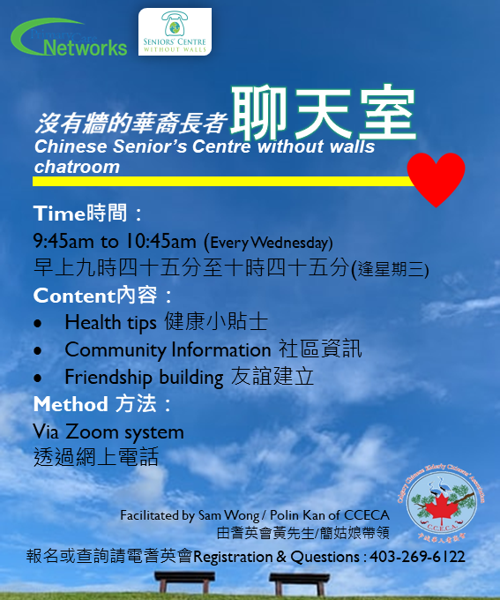Occasionally partners will approach you with a subpopulation to build programming around. They are critical to ensure appropriateness of programming and are an opportunity to involve members of the community in development and running. It does take a lot of time to establish these relationships and to get these programs off the group (months to years from idea to successful launch). As long as the partners are invested these programs, it can be a wonderful and helpful addition to your schedule. Currently, our program has three subprograms offered collaboratively: Aging with Pride, Chinese Seniors’ Centre Without Walls Chatroom, and ConnectAînés.

## 2.6 Topic Selection

Most programs offer a wide variety of programming – including educational, health, book clubs, etc. The research-focused programs tended to commit to one topic such as coping with illness or a support group atmosphere. Our program was designed to build programming and processes around participants needs and interests. Our program schedule is created every four months, though the program runs year-round, to allow for regular check ins and changes to the topics that we offer. Feedback from participants and presenters is directly incorporated into improvements and changes to the next series.

**TIP**: Looking at established SCWWs offerings can present an overwhelming diversity & scope of programs, especially when starting out. It is better to start small & tailored to the interests of your group and grow as opportunities & needs emerge. This way you ensure you choices are appropriate for your audience, & your growth keeps pace with your group.

Our pilot programming was selected using indicators in the calendar, such as holidays or awareness months, as well as the knowledge of the team/available speakers within our organization (health & wellness information, dietitian, social worker, exercise specialist) and some familiar games to our audience (BINGO, brain teasers, trivia). During our pilot, we started collecting feedback and interest topics as they arose and through our development mechanisms. We then reached out strategically to guest speakers to try create programs around topics of interest, and to develop those that worked well into regular programming.

Program topics can be one off presentations, detailing information on a topic or highlighting an organization – a presentation on falls prevention or how to declutter you house might fall under this classification. This presenter may join you once or may return later to present the same or similar topic to your participants on a regular interval – falls prevention in the Fall every year, a speaker on Elder Abuse awareness day etc. They can also be regular occurring spots of similar themes, with new activities, presenters or subjects each time – like a museum feature day, short story book club, coffee chats, world news discussion, listening to different genres/eras of radio plays or a recipe exchange. Finally, we have our set programming which offerings the same program on regular intervals for those who are interested in practicing that skill or engaging in that healthy behaviour, i.e. meditation & relaxation, home exercise support group, COPD wellness group creative writing class or English language practice group.

Overall, we classify our programming into three broad categories: Health & Wellness, Just for Fun & Skill building. Other SCWWs categorize their topics differently and looking at the program guides of other programs and local seniors’ centres can be a source of inspiration for programs looking to grow their offerings or where to begin. The goal is to mimic the range of offerings that a senior might get to experience if they were attending a typical seniors’ centre, even if they are homebound. An overview of programming offerings is below and full descriptions an amount of each offered in Appendix A.

**TIP**: SCWWs are not just presenting informative education for listening. Sessions may also include readings, games, laughter, lessons, sharing, debate, reminiscing or just friendly conversation. Don’t be afraid of trying an unconventional telephone topic and seeing how it works! No one thought telephone exercise would work and now its two of our most popular programs.

Examples of Programs Run Through Edmonton Seniors’ Centre Without Walls

|  |  |  |
| --- | --- | --- |
| Health & Wellness | Just for Fun | Skill Building |
| Home Exercise Support Group | Remembrance Day | Living Safely in Your Own Home |
| Brain Games | What in the World Is Going On? | English Language Practice Group |
| Healthy Eating | BINGO | Holistic Decluttering for Seniors |
| Changeways for Older Adults | Read Aloud Short Stories | Driving & Beyond |
| Meditation & Relaxation | Across the Miles | Money Smarts for Seniors |
| Dare to Age Well | Coffee Chats | Elder Abuse |
| Personal Wellness Through Recreation & Leisure | You're the Expert | Alberta’s Seniors Advocate |
| Strike out Stroke | Canada Day Celebration | SCWW Advisory Group |
| Meals on Wheels | Spread the Word about Public Libraries | How to start off the new year productively |
| Dental Health for Seniors | Journey Across North America to Austin Texas | Creative Writing Groups |
| Arthritis Awareness | Holidays Around the World | Music Therapy |
| Social Connectedness in Older Age | Plans for the Holidays | Housing Information for Seniors |
| Your Medication & You | Stuart McLean Stories | Caregiver Support Group |
| Stay Independent - Tips to Prevent Slips, Trips & Falls | Do You Remember When? | We're not Buying it – Scams & High-Pressure Sales Tactics |
| Seated Exercise Support Group | New Year’s Eve Games |  |
| Vision Loss | Super Sleuths |
| Living with Hearing Loss | Gratitude Group |
| Healthy Eating on a Budget | Did you Know? |
| Living Well with Diabetes | Frank Slide Museum |
| The Brain & Beyond | The Theatre Hour |
| COPD Wellness | Yukon Beringia Museum |
|  | Leduc #1 Energy Discovery Centre |
| Cross Country Canada Connections |
| Telephone Historical Centre |
| Coyote in the City |
| Alberta’s Endangered Caribou |

## 2.6 Frequency & Durations

This varies greatly between the telephone programs: some are every day, others are weekly; some are registered programs and some are ‘drop-in’, some programs have defined lengths which vary between 6-12 weeks. Within our own SCWW, our focus is more on what is the better frequency for each program topic, within our limitation of total offering capacity.

**TIP**: Depending on the climate, participation may increase in the wintertime and decrease in the summer, due to the weather and accessibility. It is up to the program as to whether their volume of programming will be consistent throughout the year.

|  |  |  |  |
| --- | --- | --- | --- |
| Biweekly | Monthly | Series-Based | Once Off |
| High interest, high number wanting to attend, invested presenter(s) or run internally. Use sparingly as schedule fills up quickly. | Regular interest, not likely to wind down. Use as first choice for popular topics, to keep the diversity of schedule but satisfy the participants selections. | Set amount of information needing to be covered on group of topics, more than can be covered in one class but not likely to be repeatedly attended. | Interest but on singular topic, unlikely to work as a series or have enough content/topics to offer more regular. Opportunity to repeat at later date. |

Even when starting out, diversity is key as there is a strong need to offer programs at various times during the day, and over multiple days throughout the week if possible. We started with offering two programs a week (a morning and an afternoon), adding offerings as our participant pool grew and we were seeing class sizes/attendance which would justify more programs. Our growth of weekly programs is shown below, as we systemically grew from two to six programs weekly.

|  |  |  |  |  |  |
| --- | --- | --- | --- | --- | --- |
|  | Monday | Tuesday | Wednesday | Thursday | Friday |
| Morning | Series 7 | Pilot  Series 1 | Series 8 | Series 2 | Series 7 |
| Early Afternoon | Series 4  Series 6 | Series 6 | Series 2 | Pilot  Series 1 | Series 9 |
| Late Afternoon | Series 3 | Series 4 | Series 8 | Series 9 | Series 6 |
| Evening | Series 10 |  | Series 10 |  | Series 10 |

The majority of SCWW calls last about 60 minutes, which in our experience, is appropriate for presenters to cover information & questions. Support groups and classes that practice a skill can be shortened to 30 minutes, as to not over-tax participants, whereas chat or discussion groups rarely end on time, so it is better to budget for 1.5hrs for budgeting of time and cost.

**TIP**: It is important to balance the amount of information, frequency of program and the maximum amount of time it is comfortable for seniors to stay on the phone. It is better to increase the frequency and shorten the length of the call if the program is regular or repeated (such as support groups, exercise or BINGO).

## 2.7 Class size

There is no single recommended number of lines on each call. Several projects suggest a maximum of 8 participants on a call and other programs appear to cap at 15. From our experience it more depends on the type of facilitation and the topic of the program. You are balancing the maximum reach of each topic, especially if it is a one off presentation, vs the ability for each individual caller to engage with the call. If the topic is mostly information based and the participants will be listening or asking questions, you can fit more participants into a call – an information session or BINGO game having a larger amount is not uncommon or unmanageable. For your average topic which has some discussion, some listening and some individual engagement, we keep a goal of 8-10 participants with an involved facilitator ensuring that all participants are able to participate to the degree they are comfortable with. For topics that are focused on building relationships between participants, class size should be kept to a minimal amount to allow them to get to know each other and self-lead the discussion with very little facilitator involvement.

Listening

15-20 participants

Engaging with Content

8-10 participants

Full Discussion

3-5 participants

Increasing need for skilled facilitation and control over call

## 2.8 Facilitation Role & Styles

**TIP**: Men can be difficult to recruit and maintain interest in the program. If they are the minority group on the phone, no matter what their own level of engagement in the discussion, they often feel the call is predominately for women. Men specific groups can help with this, though require a lot of attention and effort to get started. Other feedback we have collected indicates a perception that “talking on the phone socially” is a female coded activity.

Most telephone for seniors’ programs uses volunteer facilitators for leading the teleconferences but have at the very least the support of a service coordinator from host organization. Volunteer facilitators require established infrastructure and dedicated support, which often come after several years of operations. SCWW Edmonton’s facilitators are all paid employees of the PCN and are obviously well-trained because they do an outstanding job working with the participants! They are all very compassionate and caring individuals who are committed to their work. This is evident in all the preparatory work they do in advance of programs. All three facilitators bring a positive and refreshing attitude to their programs and are supportive and encouraging toward the seniors. The major difference among the facilitators is in how they manage participants in the context of a program. Each facilitator is unique in this regard. One facilitator is quick to redirect conversations that go off track and will occasionally talk over others to refocus the program, while another prefers a preventative approach to participant management. The other facilitator will stop a participant immediately if their comments are not relevant or are inappropriate to the topic at hand. The facilitators prefer to provide the participants with the space to speak their minds as much as possible, but will intervene as and where necessary. Some of the participants can have bad days and make the facilitators’ jobs challenging, but they are all able to manage the participants well, which is a testament to their character and training. The ability to manage participants aligns with their mandate of offering high-quality programs and ensuring that the seniors, who may be experiencing loneliness or isolation, derive the most benefit.

## 2.8.1 Policies & Procedures for in Group Emergencies

**TIP**: We would recommend a debrief with all staff involved in the project, coordinator and the supervisor to be conducted after every incident to discuss actions taken and improvements for next time. Non urgent cases can be reviewed at the next scheduled touch-base meeting, but urgent cases may require a separate meeting arranged by coordinator as soon as possible.

Just like any in person program for seniors, emergencies and incident of many natures may occur at any time both on group programming and on one on one calls. Staff should be encouraged to maintain open communication with their coordinator & supervisor and take any concerns forward so that managers can be notified and involved as needed. Staff will be provided with examples of emergency situations and appropriate responses during orientation, and these will be reviewed on a regular basis with the team as new incidents are identified. Each organization will have to come up with their own process which may include the completion of an incident report, or charting to record details of each situation and the actions taken. Our recommended areas to focus on would be:

**SECTION 1: MENTAL HEALTH**

**PURPOSE:** To ensure the mental wellbeing of all participants on the call and for staff to practice due diligence in response to incidences in group and follow-up accordingly.

**OUTCOME:** Staff will feel equipped to handle mental health situations, and will have processes to follow to manage the programs for all participants. Staff will have adequate personnel in the form of back-up facilitators support for staff and mental health support for participants.

**TIP**: Ask questions related to situation: do you have an emergency call button, do you need an ambulance, etc.? If participant goes silent after experiencing medical distress during program, staff will call 911 for all life-threatening emergencies and notify emergency contact when safe to do so. Try and get an Emergency Contact for all participants.

**SECTION 2: MEDICAL DISTRESS**

**PURPOSE:** To ensure the physical safety and wellbeing of all participants during programs (particularly exercise programs) and for staff to follow proper channels to get patients the help they need.

**OUTCOME:** Staff will have a thorough understanding of the expectations for handling emergency situations. Staff will feel equipped to handle emergency situations and will know who to notify in the event of an emergency situation.

**SECTION 3: PARTICIPANT DISCLOSURE OF INFORMATION**

**PURPOSE:** To perform an assessment risk of violence/abuse/suicide when participants disclose information or incidents to staff which raise their concerns.

**OUTCOME:** Staff will be able to assess severity of situations as they become aware of them, and take timely action. Staff will have options for expressing their concern to a second audience and involve the appropriate authorities as needed. For example, if it is determined that there is an immediate threat to the safety of the individual (active violence within the home, threat to oneself), staff will call the police and provide the address and contact information.

## 2.9 Mail-outs

**CAUTION**: This is an additional cost category to be considered. It can be difficult to predict, as each month may have a different level of programs with materials. If a program is operating on a limited budget, it is important to only send out a single package at the beginning of each month containing a calendar, highlighted with what each participant is registered in and only the bare minimum of printouts needed to participate in the programs. Work with presenters and participants to see what the essential printouts are.

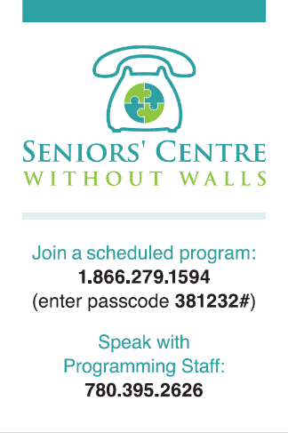To augment and support programming, we prepare mail out packages of program material for participants to follow along at home with. This can be a great tool to allow for those at home to have printed information and focus more on listening and not on writing down details. These can include fact sheets, activities, illustrations, crosswords etc. Whatever will make the presentation material more interesting and accessible for participants. As many of our seniors are experiencing vision loss to some degree, it is important to try and make most of the materials large print. Demographics of your participants is important, if your audience has more access to the internet – can you put your monthly package online and focus on those without technology for your mail-outs.

**TIP**: Mailed monthly calendars are a good reminder as well as education campaigns at the beginning of each series to train newcomers on how to join on time and on schedule. One method we used was the production of magnets (right) containing the toll-free number and passcode to reduce the number who rely on our call in.

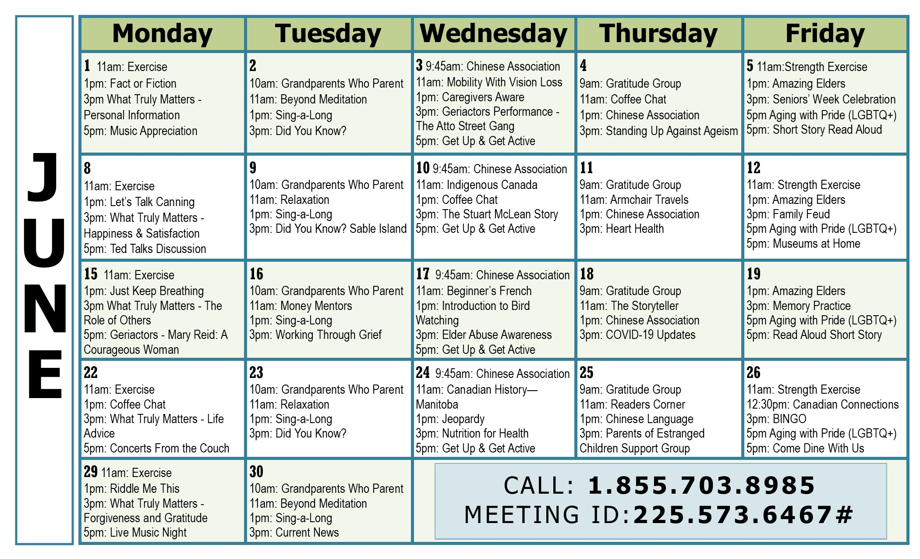

### 2.9.1 Program Books

**CAUTION**: Not everyone gets their mail on time or has it handy day of the program – no matter how early you send it out! Make sure that presenters do not make their presentations reliant on visuals in order to work (BINGO being the exception). This also keeps the accessibility open for those with vision loss.

Very early in the program development, it is important to create a template which can be updated each series, as the program grows and new programs are added. The timeframe which each book will cover is up to the group and several factors: how far ahead you can plan & schedule presenters; how often you would like to print; whether or not you will run year-round.

The contents of your program books should have everything necessary for referral partners or caregivers to understand and explain the available options to seniors, and for seniors themselves to understand how the program works, what they can get from it, what options are available to them (complete with descriptions and monthly calendars) and how they sign up for it. Appendix B contain two examples of our Program Books and their evolution between the first and later series. There are a few key elements which should always be includes and are outlined below.

1. Full description of the program, how it works and who it may be appropriate for. This can be used by referral partners/caregivers in explaining what the program is to potential participants.

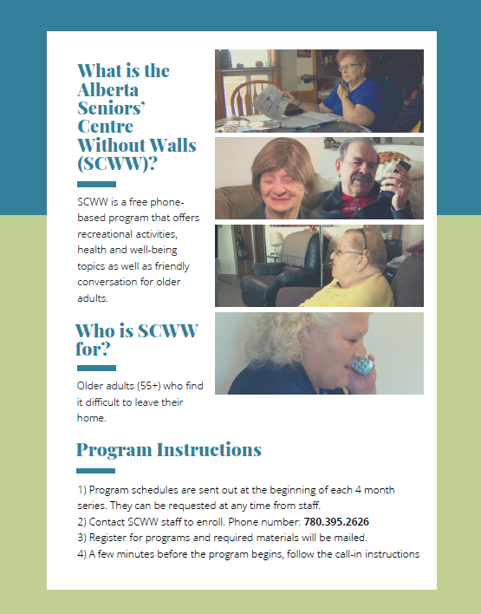

**1**

**2**

**3**

1. A nice touch is to include pictures of other participants if you have permission to share, as many participants will want to have a face to put to the voice on the phone and will not have the opportunity to meet in person.
2. Encourage registration in however many programs participants are interested in to ensure they hold their place if programs fill up quickly. Registration instructions if registration is required or being encouraged by staff.

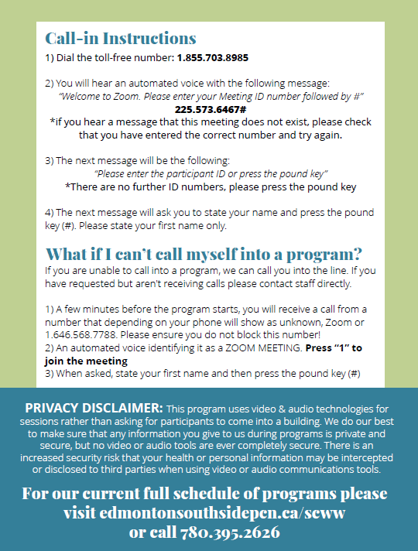

**8**

**4**

**5**

**6**

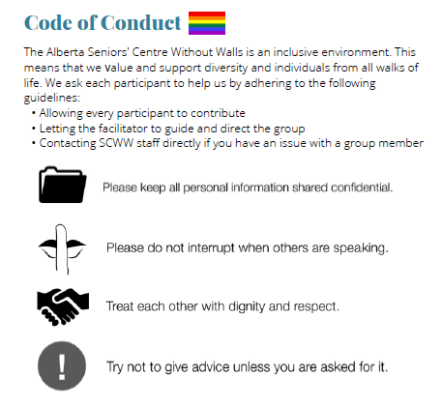

**7**

1. Call-in instructions and information, to be referred to later if individuals have misplaced their magnets/calendars or plan on using it to call themselves in.
2. Offer the call-out option to those who may be nervous about calling themselves in. Reassure potential participants/caregivers of the ease of access.
3. Include a disclaimer around the privacy risks that come with technology and the limits to what you can control as an organization.
4. Include a link to the online resource location for those who have access to technology.
5. Lay out any policies or ground rules which you plan on establishing with participants. Being able to refer to written guidelines when handling disputes or behavioural issues on the calls save the facilitators from having to get into the detail.

# 3.0 Administrative Considerations

**TIP**: Attendance is constant challenge for a telephone program, a while participating is simpler than an in-person program, there are also less steps to remind individuals to attend. The call out feature serves as a good reminder and tool for those with memory issues or who have trouble keeping to the schedule & serves to boost attendance.

## 3.1 Registration

Whether or not SCWWs require participants to register in sessions they would like to attend is up to them. In our program, participants are required to register in all sessions, every series as times and dates change. Participants do have the option to register all at once at the beginning of series or throughout as the series progresses. The purpose of this is twofold: allows staff to know who they are expected to call-out as participants, also allows the comparison of intention vs. attendance and any impact changes to outreach or education procedures has on this rate.

Depending on your organizations capacity it may make more sense to host drop-in style programs to remove the registration component unless individuals would need to be called in. Our program trialled Drop-In programming starting in March 2020 in response to the COVID-19 and the resulting influx of seniors requiring our program. With three times the seniors joining our program and the registration calls being time-consuming, we switched to drop-in once the participant had signed up with the program and provided the required intake information and emergency contacts.

## 3.2 Activity Tracking

This is again up to the organizations interests and needs, what the expectation of reporting back to funders or as overall tracking of activity and progress made on the project.

|  |  |
| --- | --- |
| Information Collected | Purpose |
| Active Participants by Series | Tracking growth and changes by seasons and maintenance/growth of active list as participants change (dropout, death, etc.) |
| Class Size | Tracking the growth and changes to class size, identify any low performing topics or ones popular enough to justify being offered more frequently. |
| Attendance Rates | Our goal was to have approximately the same as in person programs here at our organization. For our example, we set a goal of an average attendance rate of 60-65% at minimum and we have consistently had an average 63%. Can also track successes when implementing or trying new strategies of supporting attendance. |
| Attendance Growth by Number of Sessions | Checking to ensure sessions are added as needed and as justified by increased attendance. Watching for saturation points or sessions overtaking attendance growth. |
| Participant Entrance into Program | Matched with promotional activities, to see what methods work best and which need to be altered. |
| Level of Use | Track differences in attendance patterns (low, medium and high users) and the amount of time they spend in the program. Capturing level of engagement to compare outcomes by. |
| Rate of Return | Looking at drop off rate and how well participants stay in the program and when they leave. Can influence follow-up strategies and retention initiatives. |

# 4.0 Development & Evaluation

Our approach is rooted in the principles of Developmental Evaluation (DE), an approach that is well suited to a project that is in the exploratory phase, where specific outcomes are vague at best. This approach supports innovative work by enhancing the development, testing, refinement and quality of potential solutions. This is accomplished by:

1. actively gathering and documenting feedback on the impact and results of your work;
2. adopting ‘evaluative thinking’ to make sense of what that feedback is telling you, and
3. using your new understanding to make timely and necessary course corrections toward a solution that will contribute to the change you seek.

## 4.1 Participant-led Advisory Group

Due to the cyclical nature of the program’s design, the incorporation of patient feedback, ideas, and innovations will continue to improve the program into it’s future. The SCWW advisory committee is made up entirely of participants have really taken ownership over their role within the program, inquiring about the budget and feasibility, as well as sustainability of adding new policies and programs. The committee has evolved to a cohesive advisory group where they felt comfortable to disagree and/or agree with various suggestions provided and provided profound insights regarding different suggestions provided from the feedback surveys. For example:

|  |  |  |
| --- | --- | --- |
| *Feedback Cycle 1* | *Feedback Cycle 2* | *Feedback Cycle 3* |
| * Increased emphasis on the social aspects of the program - more time for organic conversation at the beginning of session, new social/free form conversation groups, trialed in-person session * More diversity and range of topics (9 of 13 suggested program topics piloted in the following series). * Added diverse programming schedule - Added mid-morning session on additional day to help accommodate competing participant preferences/needs. * New facilitators and revamped programs that participants were not satisfied with. | * Critically assessed facilitator role/style – support for peer leadership and introduction of peer lead program. * Introduced English practice group, but difficulty with varying skill level and arranging participants/scheduling. * Revamped processes of follow-up and registration calls to help with retention. * Developed male focused recruitment strategies and referral partners. | * Implemented flagging system at registration to indicate/accommodate participants who required Large Print to support those with vision loss. * Coached new participants and found out ahead of time their preferred level of participation in their first few calls, to help participants nervous about contributing. * Started a gratitude group and augmented relaxation/positive thinking program offerings to deter negative conversations. |

# 5.0 Sustainability Recommendations

|  |
| --- |
| ***Shared Vision and Plan*** |
| * Clear mission and purpose (short and long-term). * Align policies and information systems among partner organizations. * Design project using evidence-based change theory or strategy. |
| ***Project Flexibility*** |
| * Maintain project flexibility to adjust to project challenges and barriers. * Taking actions that adapt your program to ensure its ongoing effectiveness. |
| ***Monitoring, Evaluation, and Responsiveness*** |
| * Develop and conduct a comprehensive project evaluation. * Provide evidence and materials that support the program’s success to your champions to distribute. * Goal-aligned performance measures for all timeframes. * Regular assessment of community needs and the ability to use the data to respond to barriers and adapt to meet changing community needs. |
| ***Demonstrable & Communicate Effectiveness*** |
| * Demonstrate and communicate program results, successes, and wins to stakeholders, funding organizations, the media, and local government. * Quantifiable perceived value of collaboration and community health improvements among all shareholders. |
| ***Project Champions*** |
| * Recruit, train and engage community champions who will facilitate the project within their organizations and facilitate other community activities. |
| ***Human Resources*** |
| * Create a sustainable program delivery team. * Provide staff and community stakeholder training to support the building of human capital such as programming, communications & strategic planning skills. * Qualified staff included in design, implementation, evaluation, decision-making. |
| ***Managerial Support and Flexibility*** |
| * Gain the endorsement and support of collaborative organizational managers. |

|  |
| --- |
| ***Financial Resources and Financing Strategies*** |
| * Adequate, diverse, and flexible financial resources and provide for continual identification and utilization of new funding sources. * Develop fundraising strategies with partner organizations and coalition members. * Build program costs into the organizational infrastructure. |
| ***Organizational Infrastructure Development*** |
| * Align the goals of the program with those of the host organization. * Integrate project activities into the structure of the organization. * Organization capacity to enhance communication, effectiveness, efficiency (share meeting space, materials, facilitators with partners). * Heterogeneous, cooperative, respectful, trusting work environment. |
| ***Community Support for the Project*** |
| * Participation opportunities tailored to partners, community members, and external stakeholders to act as community change agents. * Diverse partnerships (multiple levels, sectors, representative of the population). * Develop community support and ownership for the project in the targeted communities. * Assess community readiness capacity for collaborative work, raise awareness, promote, and engage the community. |
| ***Political Support for Systems-Oriented Change*** |
| * Garner support of politicians, media, stakeholders, and other local champions to support social connectedness and social isolation risk reduction. * Make an impact on community policies, environments, and other capacities. * Coordinate system-wide effort to address multi-factorial problems and address evolving community needs. |

# Appendix A – Programs Frequency

|  |  |  |  |  |  |
| --- | --- | --- | --- | --- | --- |
| Health & Wellness | # of over 4 Yrs | Just for Fun | # of over 4 Yrs | Skill Building | # of over 4 Yrs |
| War on Cold & Flu | 1 | **Spread the Word** | 1 | **Action on Climate Change** | 1 |
| Health Education | 2 | **What Do YOU Watch?** | 1 | **Advocate for Change** | 1 |
| Sleep Hygiene | 1 | **Metis Identity** | 1 | **Age Friendly Edmonton** | 1 |
| Changeways | 1 | **Men’s Social Club** | 2 | **Alberta’s Seniors Advocate** | 3 |
| Strike out Stroke | 3 | **War of the Worlds** | 2 | **Arts & Trash** | 5 |
| Wellness & Leisure | 2 | **Pet Tales/Animal Features** | 10 | **Beginner French** | 5 |
| Mental Health | 2 | **Lest We Forget/Remembrance Day** | 2 | **Beyond Driving** | 2 |
| Dare to Age Well | 2 | **Do You Remember When?** | 2 | **Caregiver Aware Support Group** | 12 |
| Your Third Ear | 1 | **Vinyl Café Stuart McLean Stories** | 3 | **Combatting Ageism** | 3 |
| Vision Loss | 1 | **Coffee Chat** | 75 | **Cooking Lessons** | 3 |
| Epilepsy | 1 | **BINGO** | 42 | **COVID-19 Updates** | 4 |
| Social Connectedness | 1 | **Did you Know?** | 46 | **Creative Writing Group** | 23 |
| Arthritis Awareness | 1 | **Short Story Book Club** | 38 | **Cultivating “Hope”** | 1 |
| Parkinson’s Society | 1 | **World News (What in the World is Going On? Current News)** | 24 | **Elder Abuse** | 1 |
| Dental Health for Seniors | 1 | **Across the Miles** | 26 | **Emergency Prepared/Staying Safe in Your Home** | 3 |
| Falls Prevention | 1 | **Gratitude Group** | 11 | **English Language Practice Group** | 33 |
| Living Well with Diabetes | 1 | **Theatre Hour** | 20 | **Financial Empowerment for Seniors** | 5 |
| Wellspring Edmonton | 1 | **Super Sleuths** | 16 | **Frauds & Scams** | 1 |
| The Brain & Beyond | 1 | **Reader's Corner** | 20 | **Funeral Preplanning** | 1 |
| Brain Games/Mind Challenge | 64 | **Amazing Elders** | 7 | **Grandparents who Parent** | 4 |
| COPD Wellness | 101 | **Armchair Travels** | 11 | **Gratitude Group** | 24 |
| Get up & Get Active | 7 | **Holiday Programming** | 18 | **Holistic Decluttering for Seniors** | 3 |
| Seated Exercise | 39 | **The Storyteller** | 16 | **Housing Information for Seniors** | 4 |
| Strengthening Exercise | 27 | **Canadian History** | 7 | **How to find a good podcast** | 1 |
| Exercise | 94 | **Sing-A-Long** | 7 | **Indigenous Canada** | 1 |
| Meditation & Relaxation | 82 | **Jeopardy** | 13 | **Indoor Gardening** | 1 |
| Working through Grief | 27 | **Biographies** | 10 | **Intro to New Phone System** | 2 |
| Nutrition/Healthy Eating | 22 | **Fact or Fiction** | 6 | **Know Your Upcoming Election** | 1 |
| Happiness Basics | 4 | **Family Feud** | 9 | **Intro to Home Care** | 1 |
| Taking Control of Your Health | 8 | **Museum Talks** | 6 | **Leaving a Legacy of Values** | 1 |
| Health Chat Groups | 7 | **Comedy Club** | 4 | **Meal Deliveries** | 1 |
| Memory Practice | 20 | **Concerts from the Couch** | 8 | **Meet your Neighbours** | 3 |
| Health Support Groups | 7 | **Name that Tune** | 4 | **Memoirs** | 8 |
| Just Keep Breathing | 11 | **From the Archives** | 8 | **Movement Matters** | 1 |
|  | | **Trivial Pursuit** | 5 | **Music Therapy** | 16 |
| **You're the Expert** | 3 | **Must Have Documents** | 1 |
| **Alberta Women's Memory Project** | 5 | **Parkinson’s Association** | 1 |
| **Green & Gold Garden** | 1 | **Pillars of Pain Management** | 1 |
| **How to start off the new year productively** | 1 | **Planning to Age in Place** | 3 |
|  | | **Recipe Club** | 10 |
| **SCWW Advisory Group** | 9 |
| **Self Care Day** | 1 |
| **Seniors Benefits** | 3 |
| **Telecare** | 1 |
| **TELUS Wise** | 1 |
| **The Importance of Positivity** | 1 |
| **Tips to Prevent Slips, Trips & Falls** | 1 |
| **Trash Talk** | 1 |
| **We're not Buying it** | 1 |
| **What’s the Deal with 211?** | 1 |
| **Winter Blues** | 1 |
| **World Elder Abuse Awareness Day** | 1 |
| **You’re the Expert** | 1 |

# Appendix B – Example Program Books

Original Format



Updated Format

