Activity from “NESA: Activities Handbook for Native and Multicultural Classrooms”

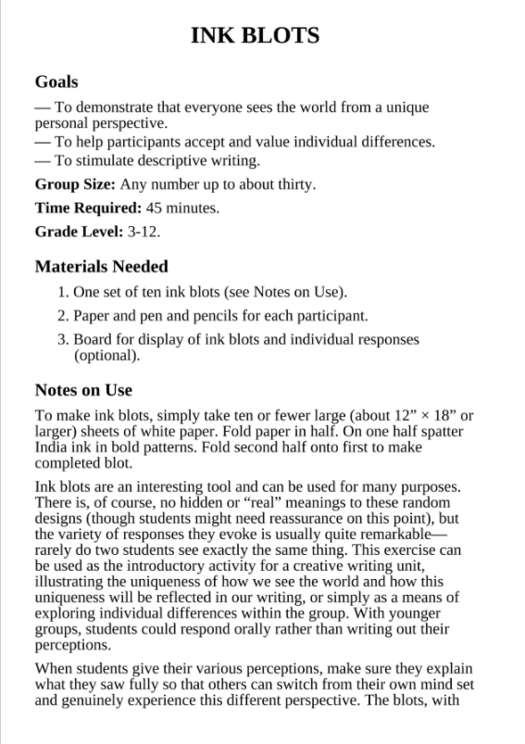

6 Ink blots provided on separate document

The students can be put in groups to discuss what they see in the ink blots before writing their own reflection. -This is optional

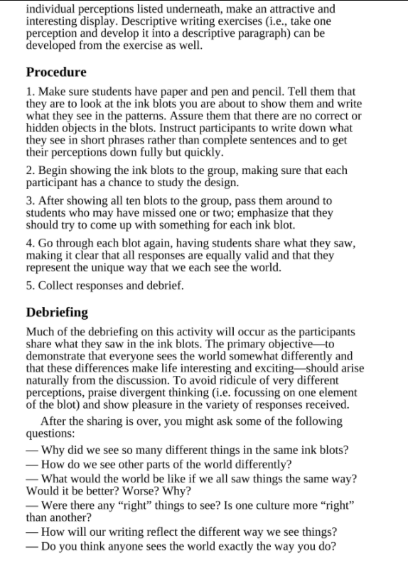
2. If students are doing group discussions, have them pick one ink blot to discuss in their group.
3. After debrief (below) students can choose an ink blot and write about what they see in the image.

