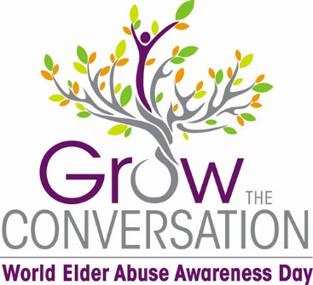

Welcome to the World Elder Abuse Awareness Day (WEAAD) Toolkit
#GrowTheConversation…Don’t Let Ageism Stop The Conversation
In the toolkit you will find:
- Social Media Guide
  - Provides you with information, stats and social media content for Facebook, Instagram and Twitter
  - Watch for more content and posts that you can share from the AEAAC Facebook and Instagram pages
- Celebration Guide
  - Provides you with information, stats and ways to raise awareness of WEAAD in your community
- Proclamation
  - Word document that your community can use to proclaim June 15th as World Elder Abuse Awareness Day
- Graphics
  - Use these on social media, websites, logos or add them to your email signature
  - Jpeg, png and pdf format
- Posters
  - Standard 8.5 x 11 page size so that you can use the posters as is or check out the one that has the white box on the bottom so that you can add your local resources/information on it
  - 11 x 17 poster
- Postcard
  - 5.5 x 8.5 that you can print and cut in half for a quick bag stuffer or a smaller poster to distribute
- Web Banners
  - There are 2 different ones to choose- one version is general and the other has a click for details feature
  - Jpeg, png and pdf formats
- Hashtags to use:
  - #ABGrowTheConversation
  - #WEAADJune15

